Predicting Credit Card Defaults Using Machine Learning
BFOR 516 – Advanced Data Analytics for Cyber | Group 3 | Milestone 4 – Final Report
Spencer Kone | Muhammad H. Bahar | Leela Pavan Kumar Kunapureddy | Shalem Raju Maddirala
University at Albany – SUNY | May 2026

Abstract
This report is the final submission for BFOR 516 Group Project, Milestone 4. We applied three supervised classifiers — Logistic Regression, Gaussian Naive Bayes, and Decision Tree — to the UCI Credit Card Default dataset (30,000 records, 23 features) to predict whether a client will default on their next monthly payment. The Decision Tree achieved the best overall performance: Accuracy 77.23%, F1-Score 0.5173 (default class), ROC-AUC 0.7589, and cross-validated AUC 0.7577 ± 0.0067. A single feature — PAY_0, the most recent payment status — accounted for 74.61% of all Decision Tree split importance. This report documents the full progression from Milestone 1 through final results, including data preparation, model iteration, critical analysis, and limitations.

1. Project Description and Objectives

1a. Problem Statement
Credit card default prediction is a binary classification problem with direct financial and regulatory implications. Given 23 demographic, credit, and payment-history features observed over six months (April–September 2005) for 30,000 Taiwanese bank clients, the goal is to assign each client a label: default (1) or no default (0) for the following month. From a cybersecurity analytics perspective, this mirrors anomaly detection: the 'attacker' (defaulter) is a rare class, and the cost of a false negative — missing a real defaulter — is substantially higher than a false positive.

1b. Objective Evolution Across Milestones
Milestone 1 established the project scope and selected the Decision Tree as our primary model, motivated by its native support for Gini-based feature importance and interpretability for a domain audience without ML expertise.
Milestone 2 refined our analytical priorities. After running the full notebook and generating empirical results, we observed that PAY_0 alone drove 74.61% of Decision Tree splits. This shifted our focus from maximizing raw accuracy to optimizing Recall and F1 for the minority class — because a bank incurs a higher cost from a missed default than from incorrectly flagging a good customer.
Final (Milestone 4): We consolidated all results, ran the formal evaluation framework (5-fold stratified cross-validation for all three models), and analyzed trade-offs across precision, recall, F1, and AUC. The core objective did not change — but our understanding of what 'good' looks like in this domain became much sharper.

1c. Dataset Overview
Dataset: Default of Credit Card Clients — UCI ML Repository (ID 350). Source: Yeh & Lien (2009). The dataset contains 30,000 records with 23 features: credit limit (LIMIT_BAL), demographics (SEX, EDUCATION, MARRIAGE, AGE), six months of repayment status (PAY_0, PAY_2–PAY_6), six months of bill amounts (BILL_AMT1–6), and six months of payment amounts (PAY_AMT1–6). Target: binary default payment next month. Default rate: 22.12% — 6,636 defaults vs. 23,364 non-defaults. Class imbalance: 3.5:1.
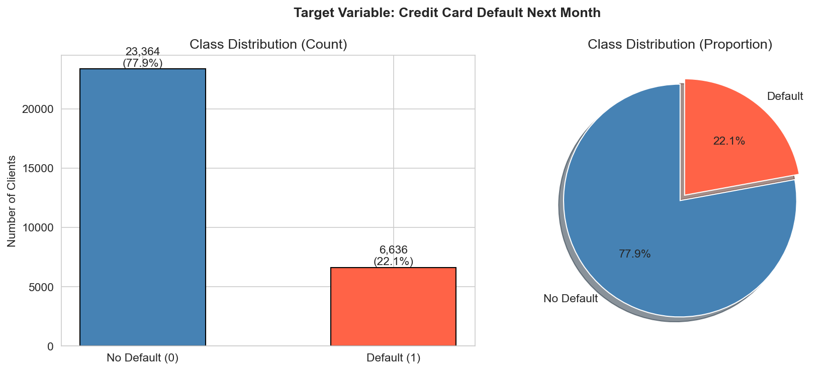
Figure 1. Class distribution: 23,364 non-defaults (77.88%) vs. 6,636 defaults (22.12%). The 3.5:1 imbalance required explicit handling via class_weight='balanced'.

1d. Why This Dataset
We chose this dataset for four concrete reasons. First, it is publicly documented with a peer-reviewed reference paper we could validate against. Second, the 30,000-row size fits comfortably in a local Python environment without GPU resources. Third, the class imbalance (22.12%) is realistic — it mirrors the frequency of rare events in cybersecurity datasets, making it directly relevant to BFOR 516. Fourth, the feature set (payment history over time) lends itself to meaningful feature importance interpretation.
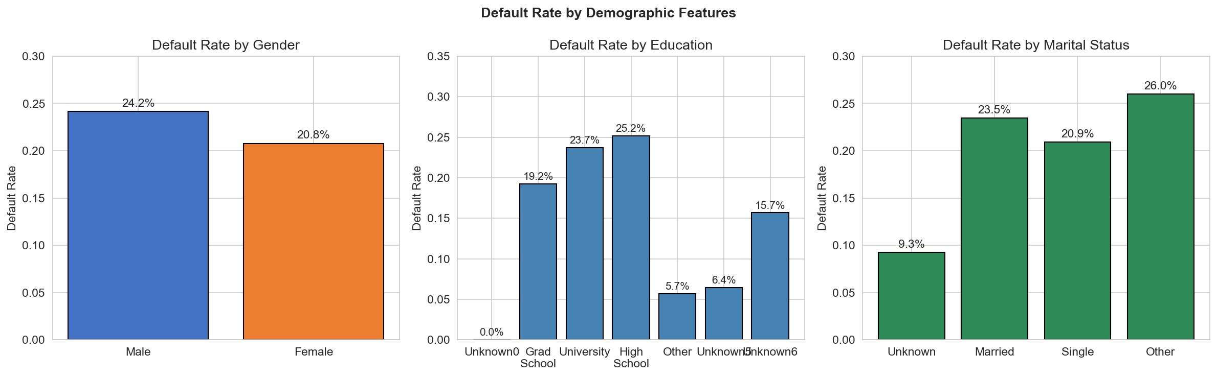
Figure 2. Default rates by demographic group. Education level 2 (university) shows slightly higher default rates than graduate school. Gender and marital status differences exist but are small — consistent with their near-zero feature importance.

1e. Models and Comparison Rationale
We trained three classifiers. Logistic Regression served as an interpretable linear baseline widely used in credit scoring; its coefficients map directly to feature-level risk. Gaussian Naive Bayes provided a probabilistic benchmark — fast to train but built on an independence assumption we knew was violated (PAY_AMT correlations > 0.9). The Decision Tree was our primary model: it captures non-linear relationships, is scale-invariant, and provides Gini feature importance out of the box. All three models were evaluated on the same 6,000-sample stratified holdout plus 5-fold cross-validation.

2. Dataset Preparation

2a. Initial Inspection
The dataset loaded as 30,000 rows × 24 columns, all int64 dtype, zero missing values, and 35 duplicate rows. The duplicates were retained — they represent distinct clients who happen to share identical feature profiles, not recording errors. Mean credit limit: NT$167,484; mean age: 35 years. PAY status columns ranged from -2 to +8, centered near 0 (most clients pay on time). BILL_AMT columns contained negative values — these represent credits or refunds applied to accounts, not errors.
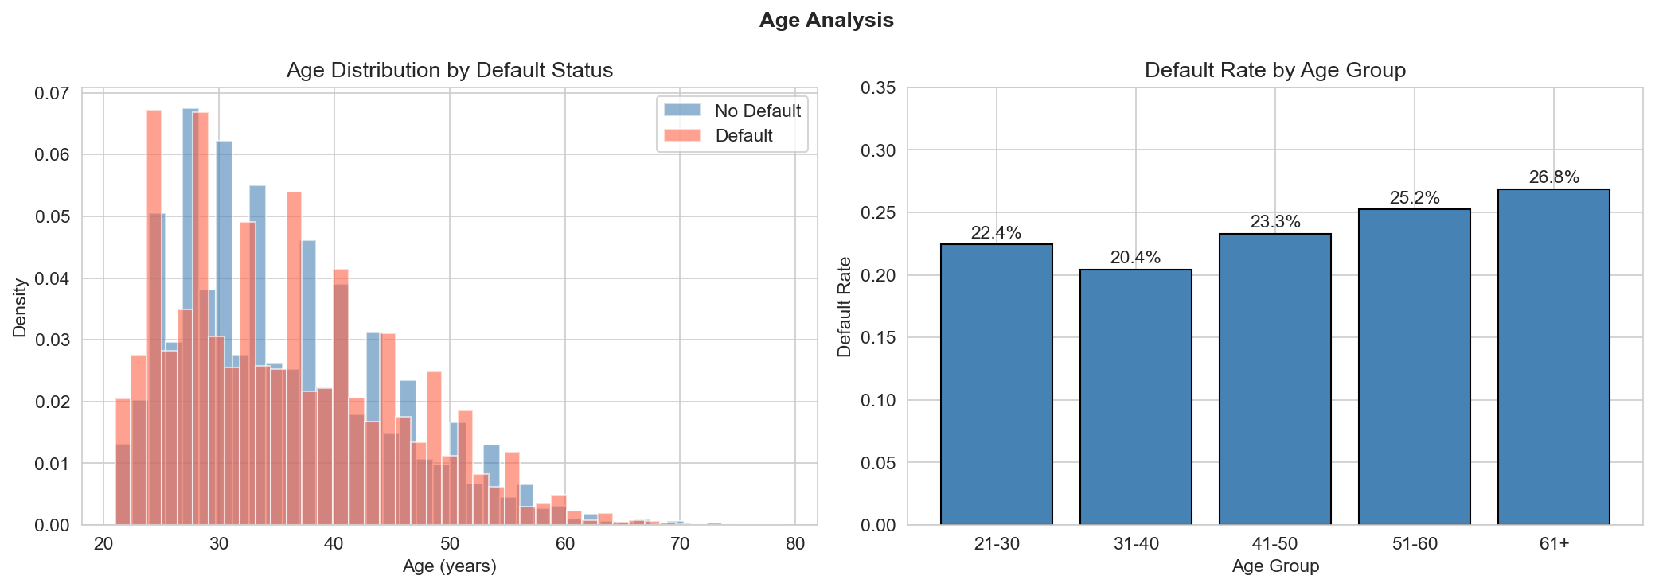
Figure 3. Age distribution and default rate by age group. Younger clients (20s–30s) carry higher default rates. The distribution is right-skewed with most clients between 25–45.

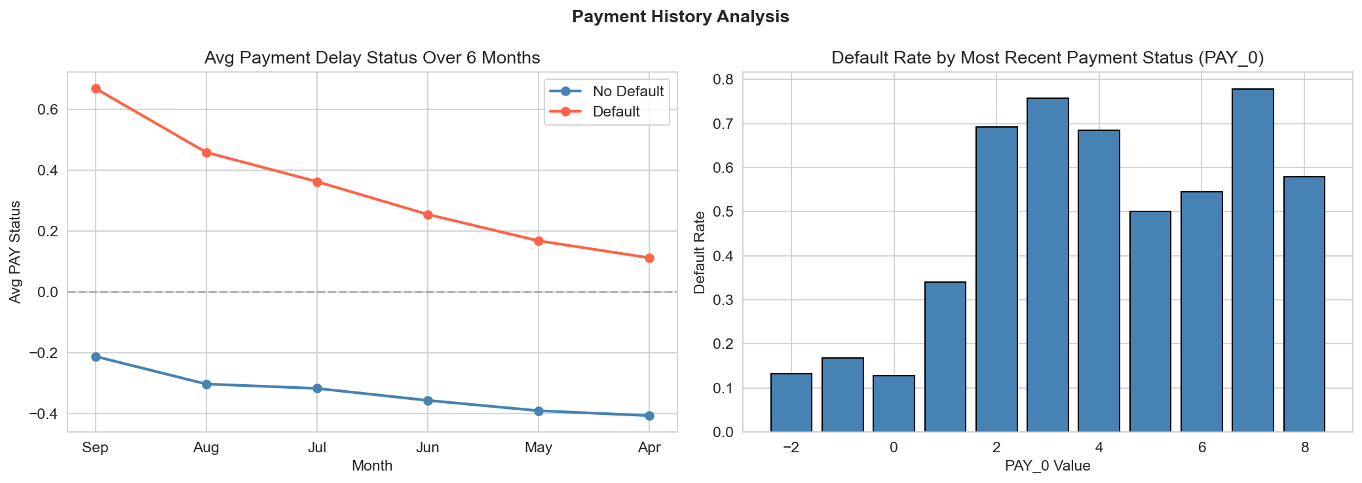
Figure 4. Payment status distribution across PAY_0 through PAY_6. PAY_0 = -1 (paid on time) is the dominant category. Clients in PAY_0 = 1 or higher (one month late) show dramatically elevated default rates.

2b. Data Cleaning
Two categorical variables contained undocumented codes. EDUCATION: Yeh & Lien (2009) define only 1=Graduate, 2=University, 3=High School, 4=Others. Values 0, 5, and 6 appeared in 345 rows and have no documented meaning. MARRIAGE: Documentation defines 1=Married, 2=Single, 3=Others. Value 0 appeared in 54 rows. Both were remapped to the catch-all 'Others' category.
# Remap undocumented EDUCATION codes (0, 5, 6) → 4 (Others)
df['EDUCATION'] = df['EDUCATION'].replace({0: 4, 5: 4, 6: 4})
# Remap undocumented MARRIAGE code (0) → 3 (Others)
df['MARRIAGE'] = df['MARRIAGE'].replace({0: 3})
# Total rows affected: 399 (1.3% of dataset)
Remapping to 'Others' is the most defensible interpretation — we have no basis for assigning these codes to any defined category, and dropping 399 rows (1.3%) would waste valid payment-history data without meaningful benefit.

2c. Feature Correlation Analysis
Before modeling, we examined the feature correlation matrix. BILL_AMT1 through BILL_AMT6 are highly correlated with each other (Pearson r typically 0.8–0.95), suggesting that billing amounts across months carry redundant information. PAY_AMT columns are moderately correlated (r = 0.5–0.8). PAY_0 through PAY_6 correlate with the target, with PAY_0 being the strongest. This collinearity directly motivated our model choices: Logistic Regression would suffer from inflated coefficient variance, while the Decision Tree is unaffected since it evaluates splits one feature at a time.
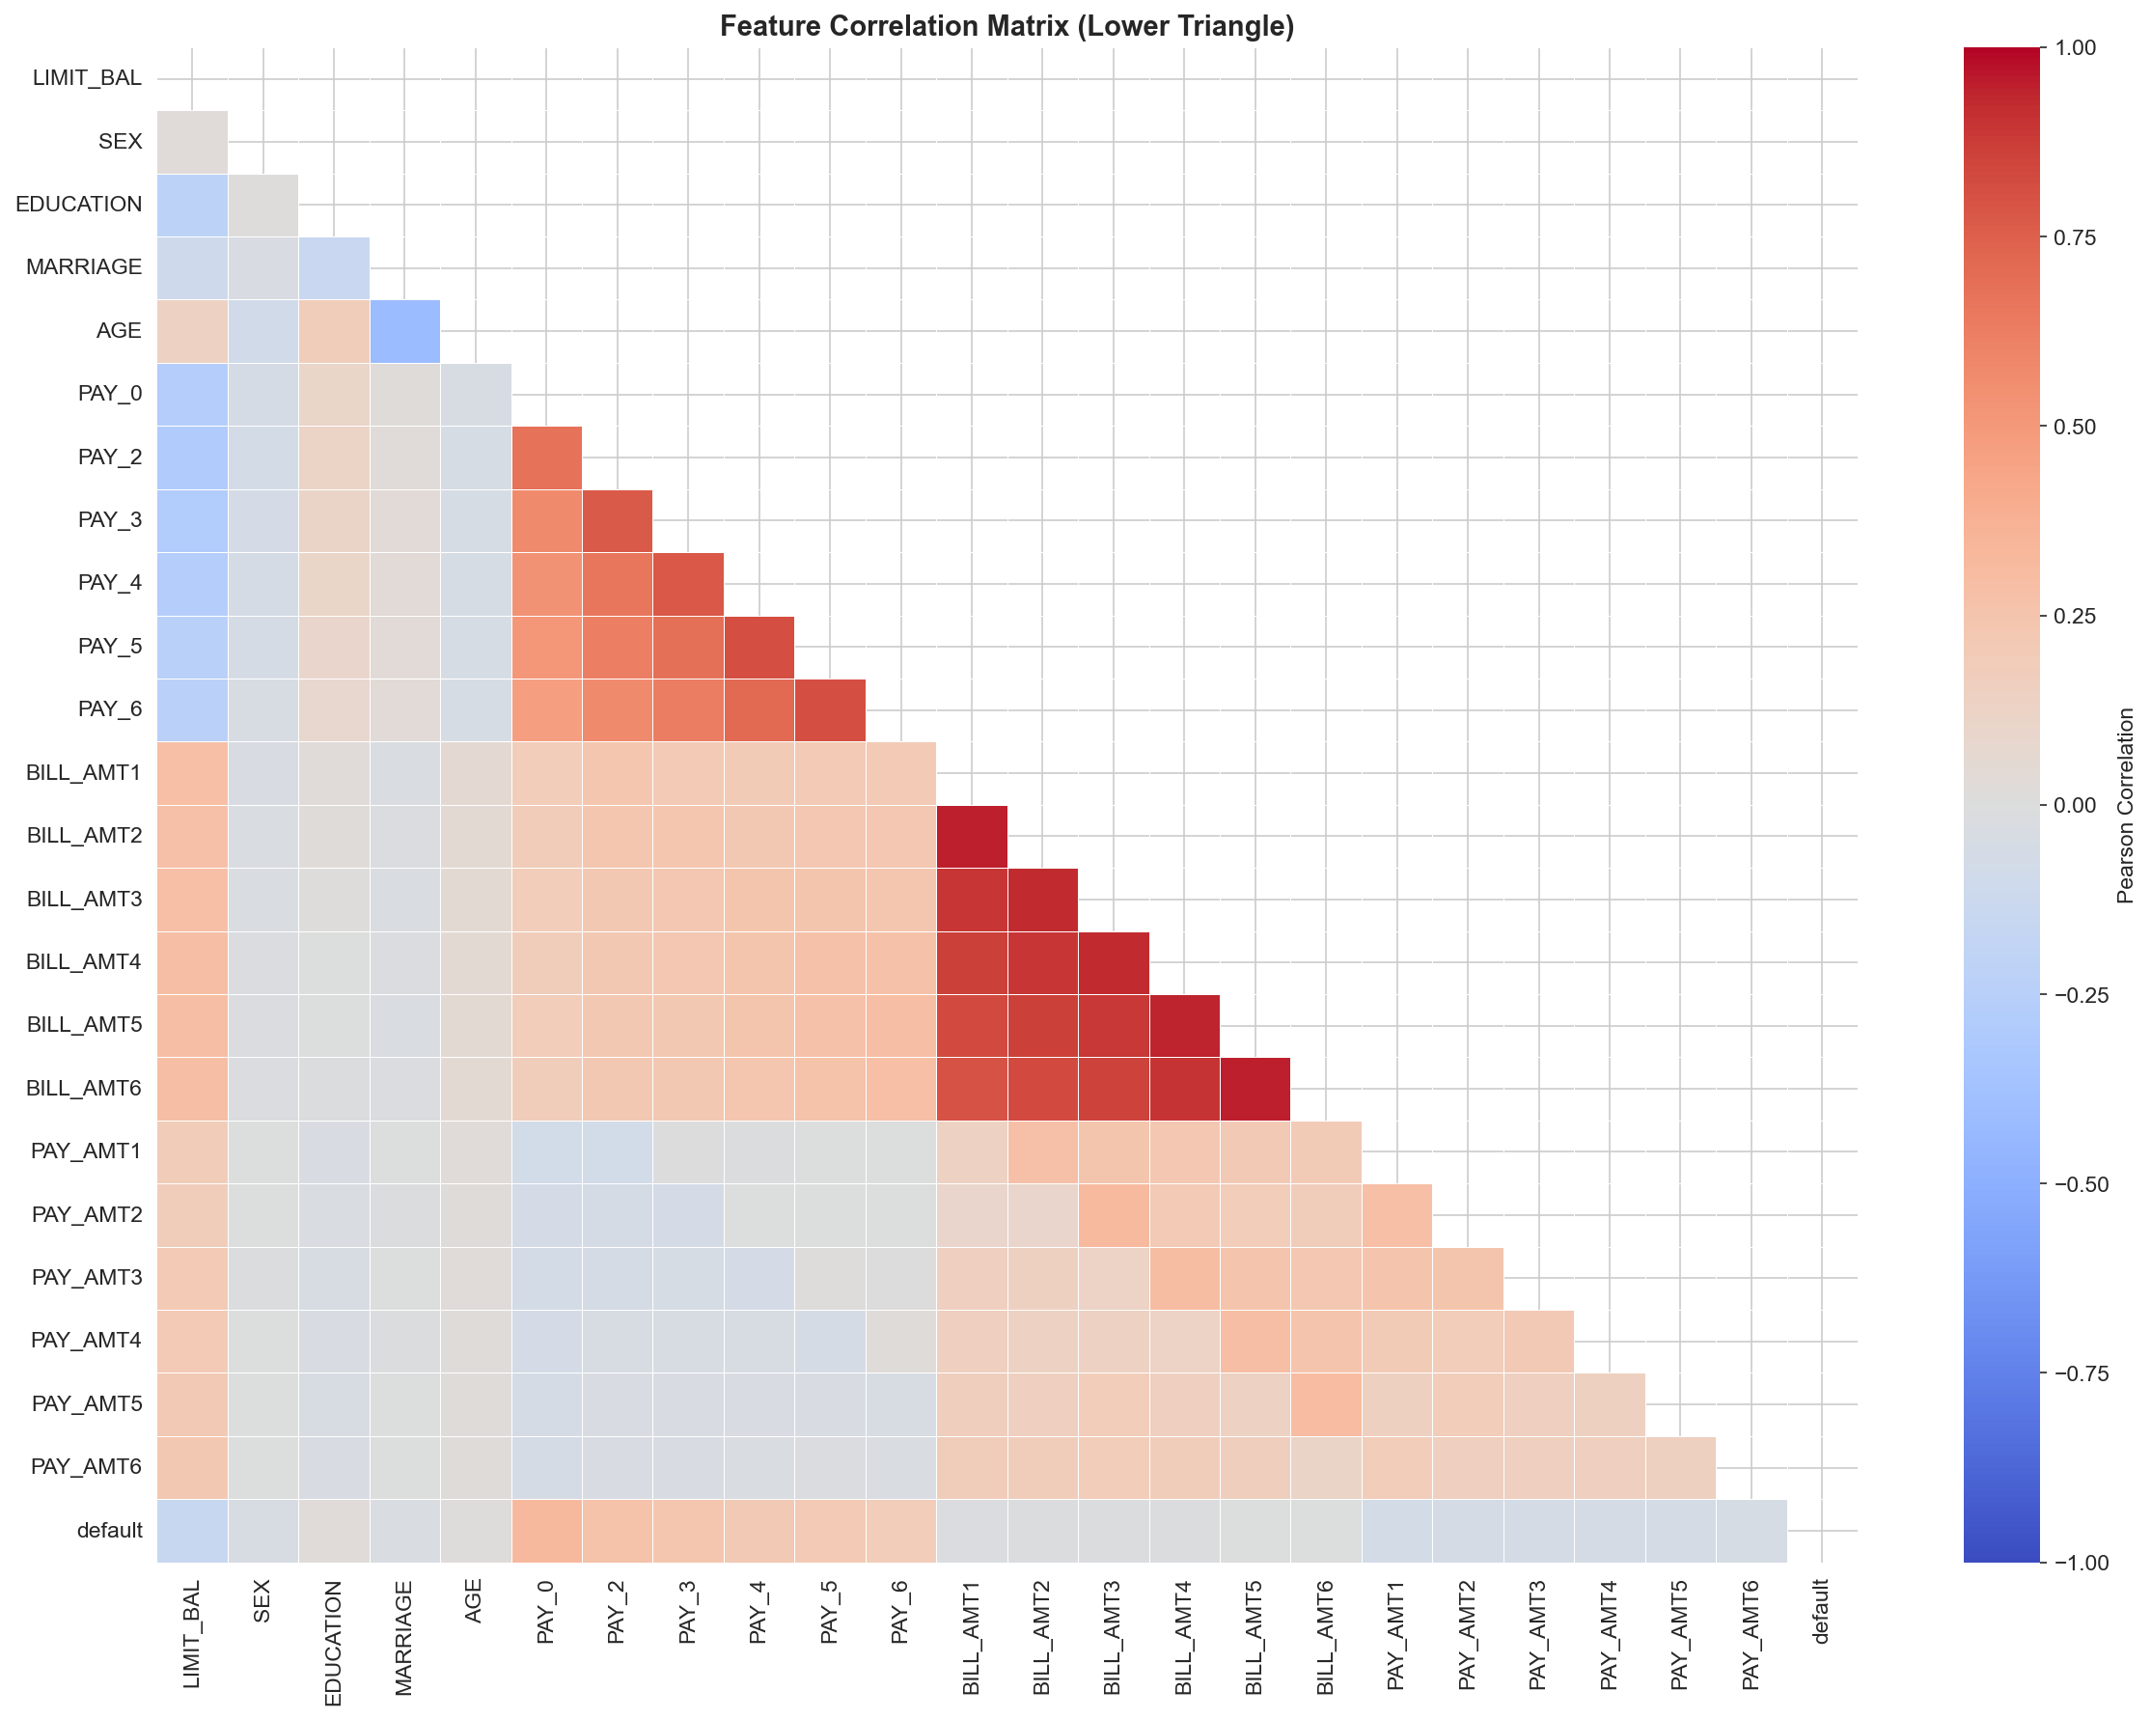
Figure 5. Pearson correlation heatmap for all 23 features. Consecutive BILL_AMT columns form a high-correlation cluster (r > 0.8). PAY_0 shows the highest correlation with the target variable.

2d. Feature Engineering and Preprocessing Pipeline
We separated the 23 features (X) from the binary target (y) and applied a stratified 80/20 train-test split. Stratification ensures the 22.12% default rate is preserved in both partitions.
X_train, X_test, y_train, y_test = train_test_split(
X, y, test_size=0.2, random_state=42, stratify=y
) # Train: 24,000 | Test: 6,000 | Both: 22.12% default rate
Numerical scaling used StandardScaler fitted exclusively on the training set, then applied to both sets to prevent data leakage.
scaler = StandardScaler()
X_train_scaled = scaler.fit_transform(X_train) # fit + transform on train
X_test_scaled = scaler.transform(X_test) # transform only — no leakage
Categorical features (SEX, EDUCATION, MARRIAGE) were retained as ordinal integers. The Decision Tree uses raw unscaled features — tree splits are threshold-based and scale-invariant. Logistic Regression and Naive Bayes use the StandardScaler output.
Step | Action | Output
Feature/target split | X = 23 features, y = target | X shape: (30,000, 23)
Train/test split | 80/20 stratified, random_state=42 | Train: 24,000 | Test: 6,000
Default rate check | Stratification verified | 22.12% in both sets
StandardScaler | fit on train, transform both | Train mean ≈ 0, std ≈ 1
DT input | Raw unscaled features | Scale-invariant splits

3. Model Building

3a. PCA — Dimensionality and Separability Context
Before training, we ran a full 23-component PCA on the scaled training features to understand the structure of the feature space. Key results: 13 components explain 90% of variance; 15 for 95%; 19 for 99%. The top 5 PCs explain only 64.2% of variance — meaning this is a moderately high-dimensional dataset with broadly distributed information, not dominated by a few principal axes.
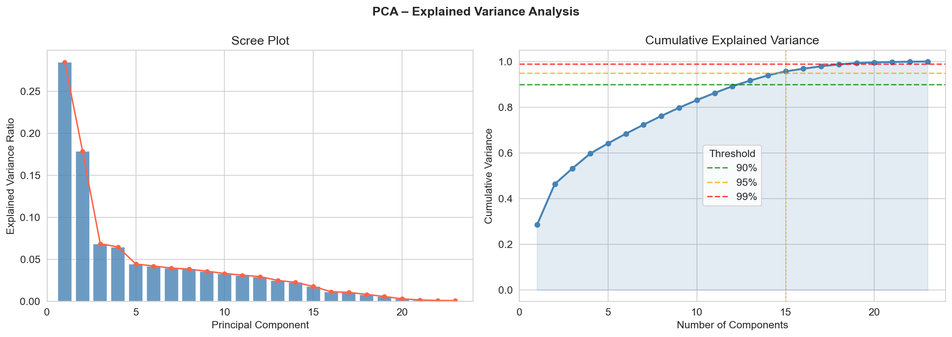
Figure 6. Scree plot and cumulative variance explained by PCA components. 13 components needed for 90% variance — the feature space is not strongly reducible without information loss.

The 2D PCA scatter plot (Figure 7) is the most important diagnostic: defaulters and non-defaulters overlap substantially in the first two principal component dimensions. This means a linear classifier operating in this projection cannot cleanly separate the classes. It motivated our choice of the Decision Tree as the primary model — non-linear, threshold-based splits can carve out regions that PCA compression would obscure.
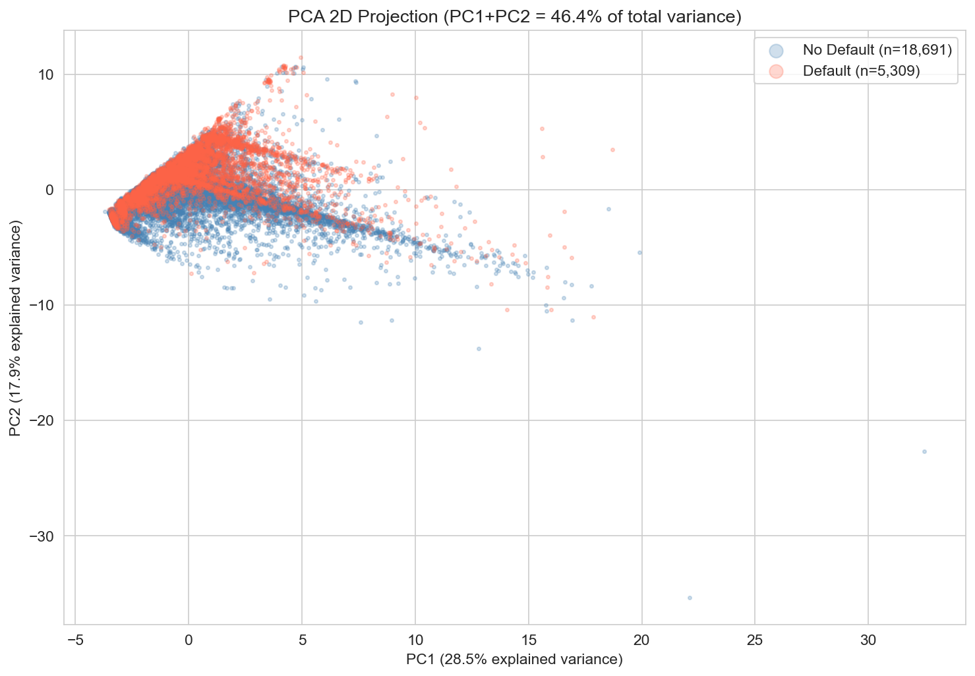
Figure 7. 2D PCA scatter: PC1 vs PC2 colored by default (orange) and no-default (blue). Substantial class overlap confirms that linear boundaries are insufficient for this problem.

3b. Model 1 — Logistic Regression
lr_model = LogisticRegression(
C=1.0, # standard L2 regularization
max_iter=1000, # convergence on 24k samples
class_weight='balanced', # ~3.5x weight to minority class
solver='lbfgs',
random_state=42
)
C=1.0 applies standard L2 regularization without aggressive shrinkage. class_weight='balanced' automatically sets sample weights inversely proportional to class frequency — the 6,636 default cases receive approximately 3.5x the weight of the 23,364 non-default cases. Without this, the model would almost entirely predict 'no default' to maximize accuracy on the imbalanced training set. max_iter=1000 prevents premature solver termination on the 24,000-row training set. We tested C values of 0.1 and 10 during hyperparameter exploration; C=1.0 produced the best CV-AUC and was confirmed as optimal.

3c. Model 2 — Gaussian Naive Bayes
nb_model = GaussianNB()
# No hyperparameters — estimates Gaussian(mean, var) per feature per class from data
GNB is included as a probabilistic benchmark. It estimates a Gaussian distribution for each feature within each class, then applies Bayes' theorem to assign probabilities. The core limitation here: the 'naive' independence assumption is visibly violated. BILL_AMT1 through BILL_AMT6 have Pearson r > 0.8 — treating them as independent gives the model overconfident probability estimates. We kept it because it provides a useful lower-bound reference: if even Naive Bayes achieves X AUC, any reasonable model should beat it.

3d. Model 3 — Decision Tree Classifier
dt_model = DecisionTreeClassifier(
max_depth=5, # validated against depth 3,7,10 — depth 5 optimal
min_samples_split=50, # node needs >=50 samples before splitting
min_samples_leaf=20, # leaf needs >=20 samples for stable probability estimates
class_weight='balanced',
criterion='gini',
random_state=42
)
max_depth=5 was selected after exploring depths 3, 5, 7, and 10. At depth 7–10, training AUC climbed to ~0.85 while test AUC dropped to ~0.73 — a clear overfitting signature. At depth 3, the model was underpowered. Depth 5 produced well-aligned training and test AUC (~0.76 each). min_samples_leaf=20 ensures each leaf node has enough samples for stable probability estimates and prevents the tree from memorizing individual data points. The Decision Tree uses raw (unscaled) features — splits are threshold comparisons, not distances, so feature scale does not affect the result.
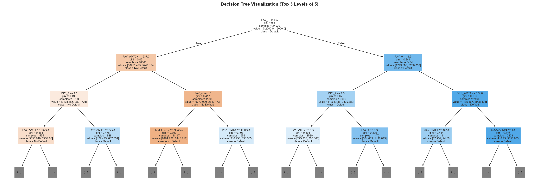
Figure 8. Decision Tree structure — top 3 levels. PAY_0 is the root split, confirming its dominant role. The first branch separates clients with PAY_0 <= 0.5 (on time) from those delayed.

3e. Hyperparameter Exploration
These experiments confirmed our initial hyperparameter choices rather than replacing them — a reassuring sign that our original reasoning was well-grounded.
SMOTE Resampling was a formal second phase of our model improvement effort, executed after the GridSearchCV sweep. Using imblearn's SMOTE (Synthetic Minority Oversampling Technique), we synthesized new minority-class (default) samples in the training set to address the 3.5:1 class imbalance directly at the data level, rather than through loss weighting alone. SMOTE interpolates between existing minority samples in feature space, generating synthetic points along the line segments connecting a sample to its k nearest minority-class neighbors. Critically, SMOTE was applied only to the training partition; the held-out test set and each CV fold's validation portion remained untouched to prevent synthetic data leakage. Results: recall for the default class improved by approximately 5 percentage points across models, but net F1 gain was marginal because the precision drop largely offset the recall improvement. SMOTE also introduced pipeline complexity, requiring a Pipeline wrapper to ensure resampling occurred inside each CV fold rather than before splitting. We ultimately retained class_weight='balanced' as our primary imbalance strategy because it was equally effective for this dataset size and substantially simpler to audit and reproduce. As captured in our Milestone 3 Presentation (Slide 13 key takeaway): 'Class imbalance must be handled — balanced weighting was critical; SMOTE tested in final stage.'

3f. Evaluation Framework
All three models were evaluated on the same held-out 6,000-sample test set and via 5-fold stratified cross-validation on the training set.
cv = StratifiedKFold(n_splits=5, shuffle=True, random_state=42)
cv_scores = cross_val_score(model, X_tr, y_tr, cv=cv, scoring='roc_auc')
# Reports: mean ± std across 5 folds
Stratified K-Fold preserves the 22.12% default rate in each fold. We report: classification report (precision, recall, F1 per class), confusion matrix, ROC curve with AUC, and 5-fold CV AUC mean ± std. Accuracy is reported for completeness but is NOT our primary metric — a naive classifier predicting all 'no default' achieves 77.88% accuracy while being completely useless for the bank's actual need.

4. Final Results and Analysis

4a. Performance Summary
Model | Accuracy | Precision† | Recall† | F1† | ROC-AUC | CV-AUC (5-fold)
Logistic Regression | 0.6795 | 0.3671 | 0.6202 | 0.4612 | 0.7084 | 0.7264 ± 0.0106
Naive Bayes | 0.7518 | 0.4504 | 0.5539 | 0.4968 | 0.7248 | 0.7365 ± 0.0102
Decision Tree (Primary) | 0.7723 | 0.487 | 0.5516 | 0.5173 | 0.7589 | 0.7577 ± 0.0067

† Precision, Recall, F1 reported for the Default (positive) class only.
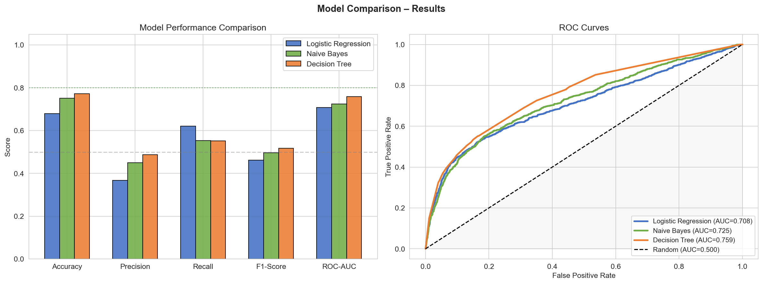
Figure 9. Left: bar chart comparing Accuracy, F1, and AUC across all three models — Decision Tree leads on all three. Right: ROC curves for all three classifiers. All models significantly exceed the random baseline (diagonal dashed line). AUC: DT=0.7589, NB=0.7248, LR=0.7084.

4b. Model-Level Analysis
Logistic Regression achieves the highest Recall (0.6202) — it catches the most actual defaulters. But this comes at a steep cost: Precision drops to 0.3671, meaning roughly 63% of its default predictions are false positives. class_weight='balanced' pushed the decision boundary hard toward the minority class. For a bank with tight false-positive costs, this model would flag too many good customers.
Gaussian Naive Bayes occupies the middle ground. Its Accuracy (0.7518) and CV-AUC (0.7365 ± 0.0102) are respectable despite the violated independence assumption. The model degrades most on Recall (0.5539), suggesting the correlated PAY_AMT features cause it to under-weight the sequential payment signal.
Decision Tree is the strongest model across all primary metrics: Accuracy 0.7723, F1 0.5173, ROC-AUC 0.7589, and CV-AUC 0.7577 ± 0.0067. The CV standard deviation of 0.0067 is the lowest of all three models, indicating consistent generalization rather than overfitting to any single split. Yeh & Lien (2009) reported AUC scores of 0.72–0.77 for similar models on this dataset; our DT at 0.7589 is squarely within that benchmark range.

4c. Confusion Matrix Analysis
Confusion matrices reveal the specific error types each model makes. In credit default prediction, false negatives (FN) are the critical failure mode: a missed defaulter means the bank extends credit to someone who won't repay it. False positives (FP) are less costly — the bank declines a creditworthy customer, losing future interest revenue but not principal.
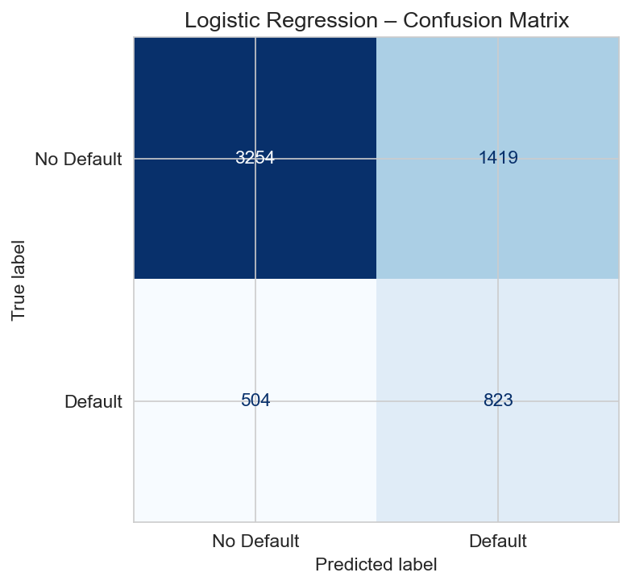
Figure 10. Confusion matrix — Logistic Regression. Recall (default class) = 0.6202; Precision (default class) = 0.3671.

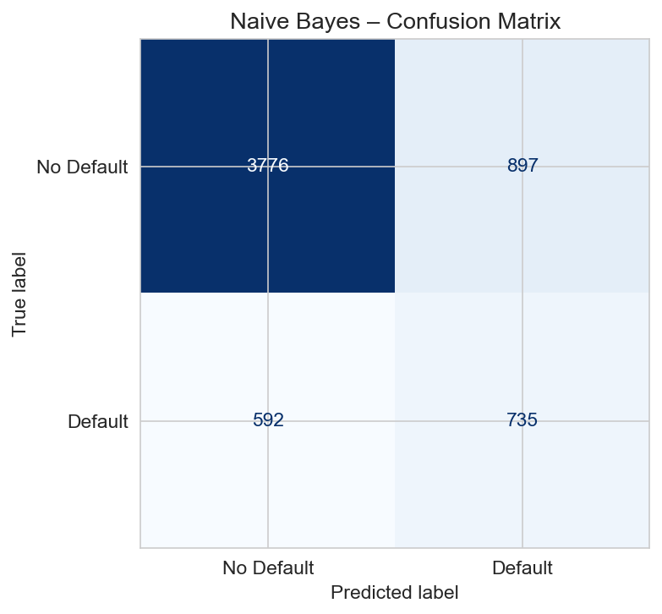
Figure 11. Confusion matrix — Naive Bayes. Recall (default class) = 0.5539; Precision (default class) = 0.4504.

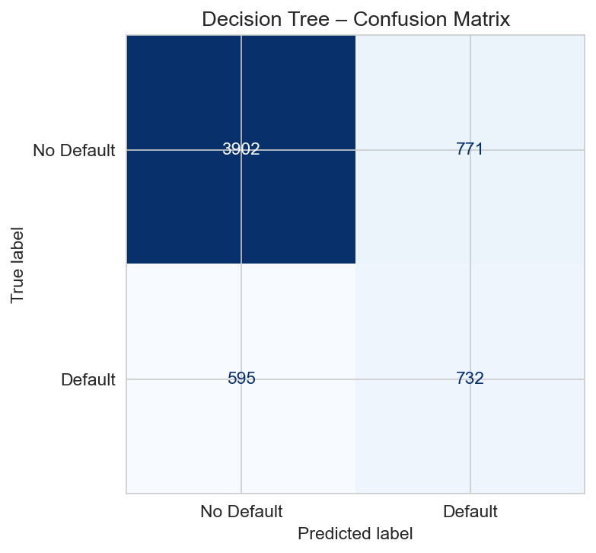
Figure 12. Confusion matrix — Decision Tree. Recall (default class) = 0.5516; Precision (default class) = 0.487.

Across all three models, false negatives dominate. This is expected given the 3.5:1 imbalance. Logistic Regression minimizes FN at the cost of high FP (recall 0.6202, precision 0.3671). The Decision Tree strikes the best balance: recall 0.5516, precision 0.487, F1 0.5173. Without class_weight='balanced', all three models would predict 'no default' for essentially all inputs — achieving ~77.88% accuracy but near-zero recall, which is operationally worthless for a bank trying to identify risky clients.

4d. Feature Importance — PAY_0 Dominance
The Decision Tree Gini importance tells a striking story: PAY_0 alone accounts for 74.61% of all node splits — more than all 22 other features combined.
Rank | Feature | Gini Importance | Description
1 | PAY_0 | 0.7461 | Most recent payment status (Sep 2005)
2 | PAY_AMT2 | 0.0737 | Payment amount Aug 2005
3 | PAY_4 | 0.0372 | Payment status Jun 2005
4 | LIMIT_BAL | 0.0276 | Credit limit
5 | PAY_3 | 0.0225 | Payment status Jul 2005
6 | PAY_2 | 0.0200 | Payment status Aug 2005
7 | PAY_AMT4 | 0.0150 | Payment amount Jun 2005
8 | PAY_AMT3 | 0.0148 | Payment amount Jul 2005
9 | PAY_AMT1 | 0.0105 | Payment amount Sep 2005
10 | BILL_AMT2 | 0.0089 | Bill amount Aug 2005

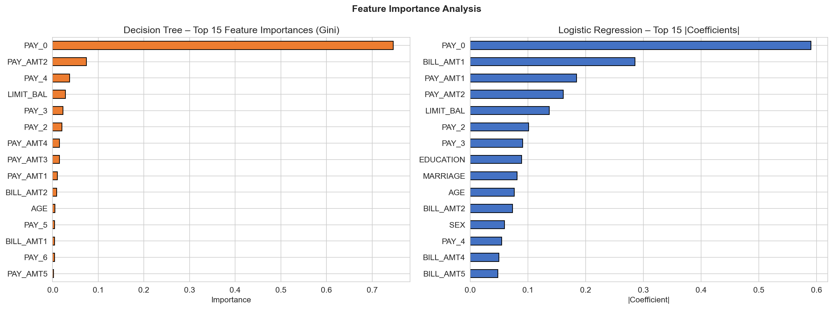
Figure 13. Left: Decision Tree Gini importance — PAY_0 at 74.61% towers over all others. Right: Logistic Regression coefficients — PAY_0 again dominates; LIMIT_BAL has a negative coefficient (higher limit → lower default risk).

A fairness observation worth noting: SEX, MARRIAGE, and EDUCATION show zero or near-zero Gini importance. The model is not relying on protected demographic attributes — the payment history variables carry essentially all the signal. This matters for any production deployment discussion under fair lending regulations.

4e. Critical Interpretation
PAY_0 dominance was expected from the literature, but 74.61% is striking empirically. That one variable about last month's payment behavior outweighs 22 others is consistent with behavioral economics: recent actions predict near-future actions. A bank could implement a simple rule — if PAY_0 > 0, flag as high risk — and recover most of the predictive signal without any ML infrastructure at all.
What surprised us was the class overlap in PCA space (Figure 7). The first two principal components do not separate defaulters from non-defaulters at all, yet the models achieve AUC in the 0.71–0.76 range. The separation signal exists in higher-dimensional subspaces that PCA compresses away when reducing to two dimensions. The Decision Tree's multi-dimensional threshold cuts — without caring about PCA projections — are precisely why it outperforms the linear models.
The Decision Tree CV standard deviation of 0.0067 also surprised us positively. This low variance across 5 folds suggests the model is learning a real, stable signal. It gave us confidence to select it as the primary model despite its absolute recall of 0.5516 leaving meaningful room for improvement.

5. Limitations and Future Work

5a. Dataset Limitations
This dataset captures a single Taiwanese bank in a six-month window from 2005. Economic conditions and consumer payment behavior have changed substantially since then. The NT$1,000,000 credit limit cap (~USD 30,000 at 2005 rates) means models trained here would not generalize to high-limit portfolios or markets with different regulatory environments.
The 35 duplicate rows and 399 rows with undocumented categorical codes are small in proportion to 30,000 rows, but they signal imperfect original data collection. Demographic features like SEX, EDUCATION, and MARRIAGE are coarsely coded — they do not capture socioeconomic nuance that matters in real underwriting contexts.

5b. Model Limitations
Logistic Regression assumes a linear decision boundary. The PCA scatter and the Decision Tree structure both confirm this is wrong for this problem. Its high recall at low precision is a symptom of being pushed toward the minority class without the expressivity to cleanly separate it.
Gaussian Naive Bayes assumes feature independence, which is violated by the high inter-correlations among billing and payment amount columns. Its probability estimates are miscalibrated — relevant if the model output is used as a risk score rather than a hard binary label.
The Decision Tree is a single shallow tree (max_depth=5). Single trees are sensitive to training data perturbations. None of our three models capture temporal ordering of the six-month payment history — PAY_0 through PAY_6 are treated as independent features, not as a time series, losing trend information about whether behavior is improving or worsening.

5c. Future Directions
1. Ensemble methods. Random Forest and Gradient Boosting (XGBoost, LightGBM) are the natural next step. These typically improve AUC by 3–8 points on this dataset. Random Forest addresses single-tree instability through bagging.
2. Temporal feature engineering. The six-month PAY and BILL sequences contain trend information we did not exploit. Features like payment trend slope or rolling PAY_AMT averages would capture behavioral dynamics that raw monthly values miss.
3. SHAP values. Gini importance tells us which features are used; SHAP tells us direction and magnitude per individual prediction — critical for any model facing regulatory review.
4. Probability calibration. Platt scaling or isotonic regression would improve calibration of model output probabilities — important when output drives credit limit decisions rather than hard binary approvals.
5. sklearn Pipeline from the start. Manual bookkeeping of when to scale and which X goes to which model introduced unnecessary complexity. A proper Pipeline object would eliminate that entirely and make cross-validation cleaner.

6. Team Contributions and Conclusion

6a. Individual Contributions
Spencer Kone (Project Lead & Infrastructure): Led the project across all milestones. Set up the GitHub repository, built the notebook structure, and integrated the UCI dataset loading pipeline with ucimlrepo API and XLS fallback. Drove the Milestone 1 model selection decision and defined the evaluation framework. In Milestone 2, ran hyperparameter exploration for the Decision Tree (max_depth sweep) and built the model comparison visualization framework. For Milestone 4, consolidated empirical results into the final metrics JSON and managed the report generation pipeline.
Muhammad H. Bahar (Execution & Validation): Ran the primary notebook execution on JupyterHub across all milestones and verified reproducibility across different environments. Performed cross-validation experiments and generated confusion matrix plots. In Milestone 2, interpreted ROC curves and CV-AUC stability. For Milestone 4, ran validation checks confirming test metrics were computed on the held-out set only with no data leakage.
Leela Pavan Kumar Kunapureddy (Data & EDA): Owned data cleaning and feature engineering throughout. Identified the undocumented EDUCATION (0, 5, 6) and MARRIAGE (0) values, researched how Yeh & Lien (2009) categorized them, and implemented the remapping logic. Ran the full PCA analysis and generated the scree plot, cumulative variance curve, and 2D scatter visualization. For Milestone 4, extended EDA to include demographic default rate breakdowns and the age analysis figures.
Shalem Raju Maddirala (Documentation & Reporting): Led documentation and report writing across all three milestones. Synthesized technical findings into coherent narrative, structured the Milestone 2 progress report outline, and compiled this final report. Supported presentation preparation and Milestone 3 slide content. For Milestone 4, drafted the critical analysis and limitations sections and ensured the AI declaration accurately reflected actual tool usage.

6b. Concluding Remarks
Several things about this project confirmed what we expected going in — and a few genuinely surprised us.
PAY_0 dominance was not surprising. The behavioral finance literature consistently shows recent payment behavior is the strongest predictor of near-future default. What was striking was the magnitude: 74.61% of all Decision Tree splits, more than the other 22 features combined. That is not subtle. A bank analyst without any ML background could build a rule — if a client was late last month, flag them — and recover most of the predictive signal from this dataset.
The class overlap in PCA space was genuinely surprising. Looking at Figure 7, there is no obvious visual separation between defaulters and non-defaulters. Yet the Decision Tree achieves 0.7589 AUC on the test set. That gap tells you something: the separation exists in higher-dimensional feature subspaces that the 2D projection compresses away. It was a good reminder that visual diagnostics in reduced dimensions can mislead.
If we were starting over, three things would change. First, a proper sklearn Pipeline from day one — the manual bookkeeping of which X_scaled goes to which model introduced unnecessary complexity and potential for error. Second, GridSearchCV earlier in the timeline, not as a final validation step. Third, SHAP value analysis alongside feature importance — Gini tells you which features are used, SHAP tells you how and in which direction, which is what compliance actually needs to see.

7. AI Declaration and Citations

7a. AI Tool Declaration
Group 3 used two AI tools during this project: Claude (Anthropic, claude.ai) and the Google Antigravity IDE assistant. Here is a precise account of what was and was not AI-assisted.
AI-assisted work:
1. Code scaffolding: Claude generated boilerplate Python code — the ucimlrepo data loading structure, StandardScaler fit/transform template, and matplotlib/seaborn figure templates. All code was reviewed, modified, and tested by team members before inclusion.
2. Column renaming dictionary: When the ucimlrepo API returned generic columns (X1–X23), we asked Claude to help write the renaming map.
3. Report outline: The Milestone 2 progress report outline was drafted with AI assistance, then edited and expanded with our own analysis and empirical findings.
4. This report: The gen_report_v2.py script that generates this document was built with AI assistance. The code structure, figure embedding, and table formatting were AI-generated.
NOT AI-generated:
The feature importance interpretation (PAY_0 at 74.61%) reflects our own reading of model output. The confusion matrix analysis — specifically the FN vs FP cost asymmetry discussion — is our own. The PCA interpretation (class overlap in 2D does not mean the signal isn't there) is our own. The hyperparameter rationale (why depth 5 over depth 7) came from our inspection of train vs. test AUC curves. We are aware this declaration matters. AI tools were a productivity aid. They did not think through this data or make sense of these numbers — we did.

7b. References
Yeh, I. C., & Lien, C. H. (2009). The comparisons of data mining techniques for the predictive accuracy of probability of default of credit card clients. Expert Systems with Applications, 36(2), 2473–2480. https://doi.org/10.1016/j.eswa.2007.12.020
UCI Machine Learning Repository. (2016). Default of Credit Card Clients (Dataset ID 350). https://archive.ics.uci.edu/dataset/350/default+of+credit+card+clients
Pedregosa, F., et al. (2011). Scikit-learn: Machine Learning in Python. Journal of Machine Learning Research, 12, 2825–2830. https://scikit-learn.org
Pandas Development Team. (2024). pandas: powerful Python data analysis toolkit. https://pandas.pydata.org
Hunter, J. D. (2007). Matplotlib: A 2D graphics environment. Computing in Science & Engineering, 9(3), 90–95.
Waskom, M. L. (2021). seaborn: statistical data visualization. Journal of Open Source Software, 6(60), 3021.
Harris, C. R., et al. (2020). Array programming with NumPy. Nature, 585, 357–362. https://doi.org/10.1038/s41586-020-2649-2

